CSIT314 Software Development Methodologies - Group Project

Sprint 2 - US14: Create company profile
Interior Design Platform - Interior Designer
All diagrams were drawn in draw.io. Open "US14 Create company profile.drawio" in this folder to edit them - each diagram is its own page in that file. The exported images are in the "diagrams" folder.

Assumptions
- The system is the Interior Design Platform from the project specification. Sprint 2 covers the Interior Designer's log in, company profile and log out stories (US13 - US19) and the Platform Manager's log in, log out and IDP category stories (US39 - US45).
- A company profile belongs to one interior designer account. It has a company name, description, services offered, contact email, contact phone, address, the date it was created, a status (Active or Suspended) and a revision number. It is saved in the company_profile table.
- We follow B-C-E: the actor only talks to the boundary (page), the boundary only talks to the controller, and the controller works with the entity classes. There is one controller per use case.
- The boundary checks all the input (required fields, lengths, formats, e.g. not suspending your own profile) and trims spaces, then passes an entity object on. The controller just calls the entity and returns the result. The entity checks for duplicates and the database state (e.g. name already used, only Active rows are changed), then saves. In US14 the page trims and checks every field with getFieldErrors(companyProfile) (the shared field rules in createCompanyProfilePage.py) and builds a CompanyProfile, CreateCompanyProfileController only calls CompanyProfile.createCompanyProfile(), and the entity refuses a second row for the same designer.
- Company name (3 - 100 characters), description (up to 2000) and services (up to 1000) are required. Email (up to 254, must look like an email), phone (up to 30) and address (up to 300) are optional. The page removes the spaces at the start and end before it checks them.
- Each designer has at most one company profile (designerId is UNIQUE in the company_profile table). If the designer already has a row - Active, or Suspended after a delete (US17) - createCompanyProfile() returns False and the page shows "You already have a company profile". A deleted profile is brought back with Restore on the dashboard (US17), not created again.
- The create form opens straight away - there is no "do you already have a profile?" check before it. The dashboard only shows the Create button when the designer has no profile (UC13 asks US15's and US17-R's controllers what to show).
- A designer can only use their own company profile. The owner always comes from the logged-in session, so a designerId or companyId put in the URL or the form is ignored.
- Logged in as an interior designer (UC13) is the precondition. designerLoginRequired in app.py only sends someone with no session to /designer/login; the use case doesn't check the designer again.
- database/seedCompanyData.py adds 100 demo designer accounts with one company profile each, for testing the later stories. Running it again doesn't add duplicates.

1. User story
Story ID | US14
User story | As an interior designer, I want to create a company profile so that customers can learn about my company and its services.
Actor | Interior Designer
Priority | High
Story points (estimate) | 3
Acceptance criteria | 1. Given I am on the designer dashboard and have no company profile, there is a "Create company profile" button that opens an empty form.  2. The form has company name, company description, services offered, contact email, contact phone and company address. The first three are required.  3. Given I fill in the form correctly and click "Create company profile", then the profile is saved, I go back to the dashboard and see "Company profile created successfully".  4. Given a required field is empty, a field is too long or the email isn't valid, then I see "Please fix the highlighted fields", the wrong fields are highlighted, what I typed is kept and nothing is saved.  5. Given I already have a company profile (Active, or deleted and not restored yet), when I save the form, then I see "You already have a company profile" and nothing is saved or changed.  6. Given I click "Cancel", then I go back to the dashboard and nothing is saved.
Tasks | #97 Draw Create Company Profile Use Case Diagram  #98 Write Create Company Profile Use Case Description  #99 Draw Create Company Profile BCE Diagram  #100 Draw Create Company Profile Sequence Diagram  #101 Design Create Company Profile Wireframe  #102 Write and Execute Create Company Profile Test Cases

2. Use case diagram
The user story becomes one use case, UC14 Create company profile. The Interior Designer is the only actor.
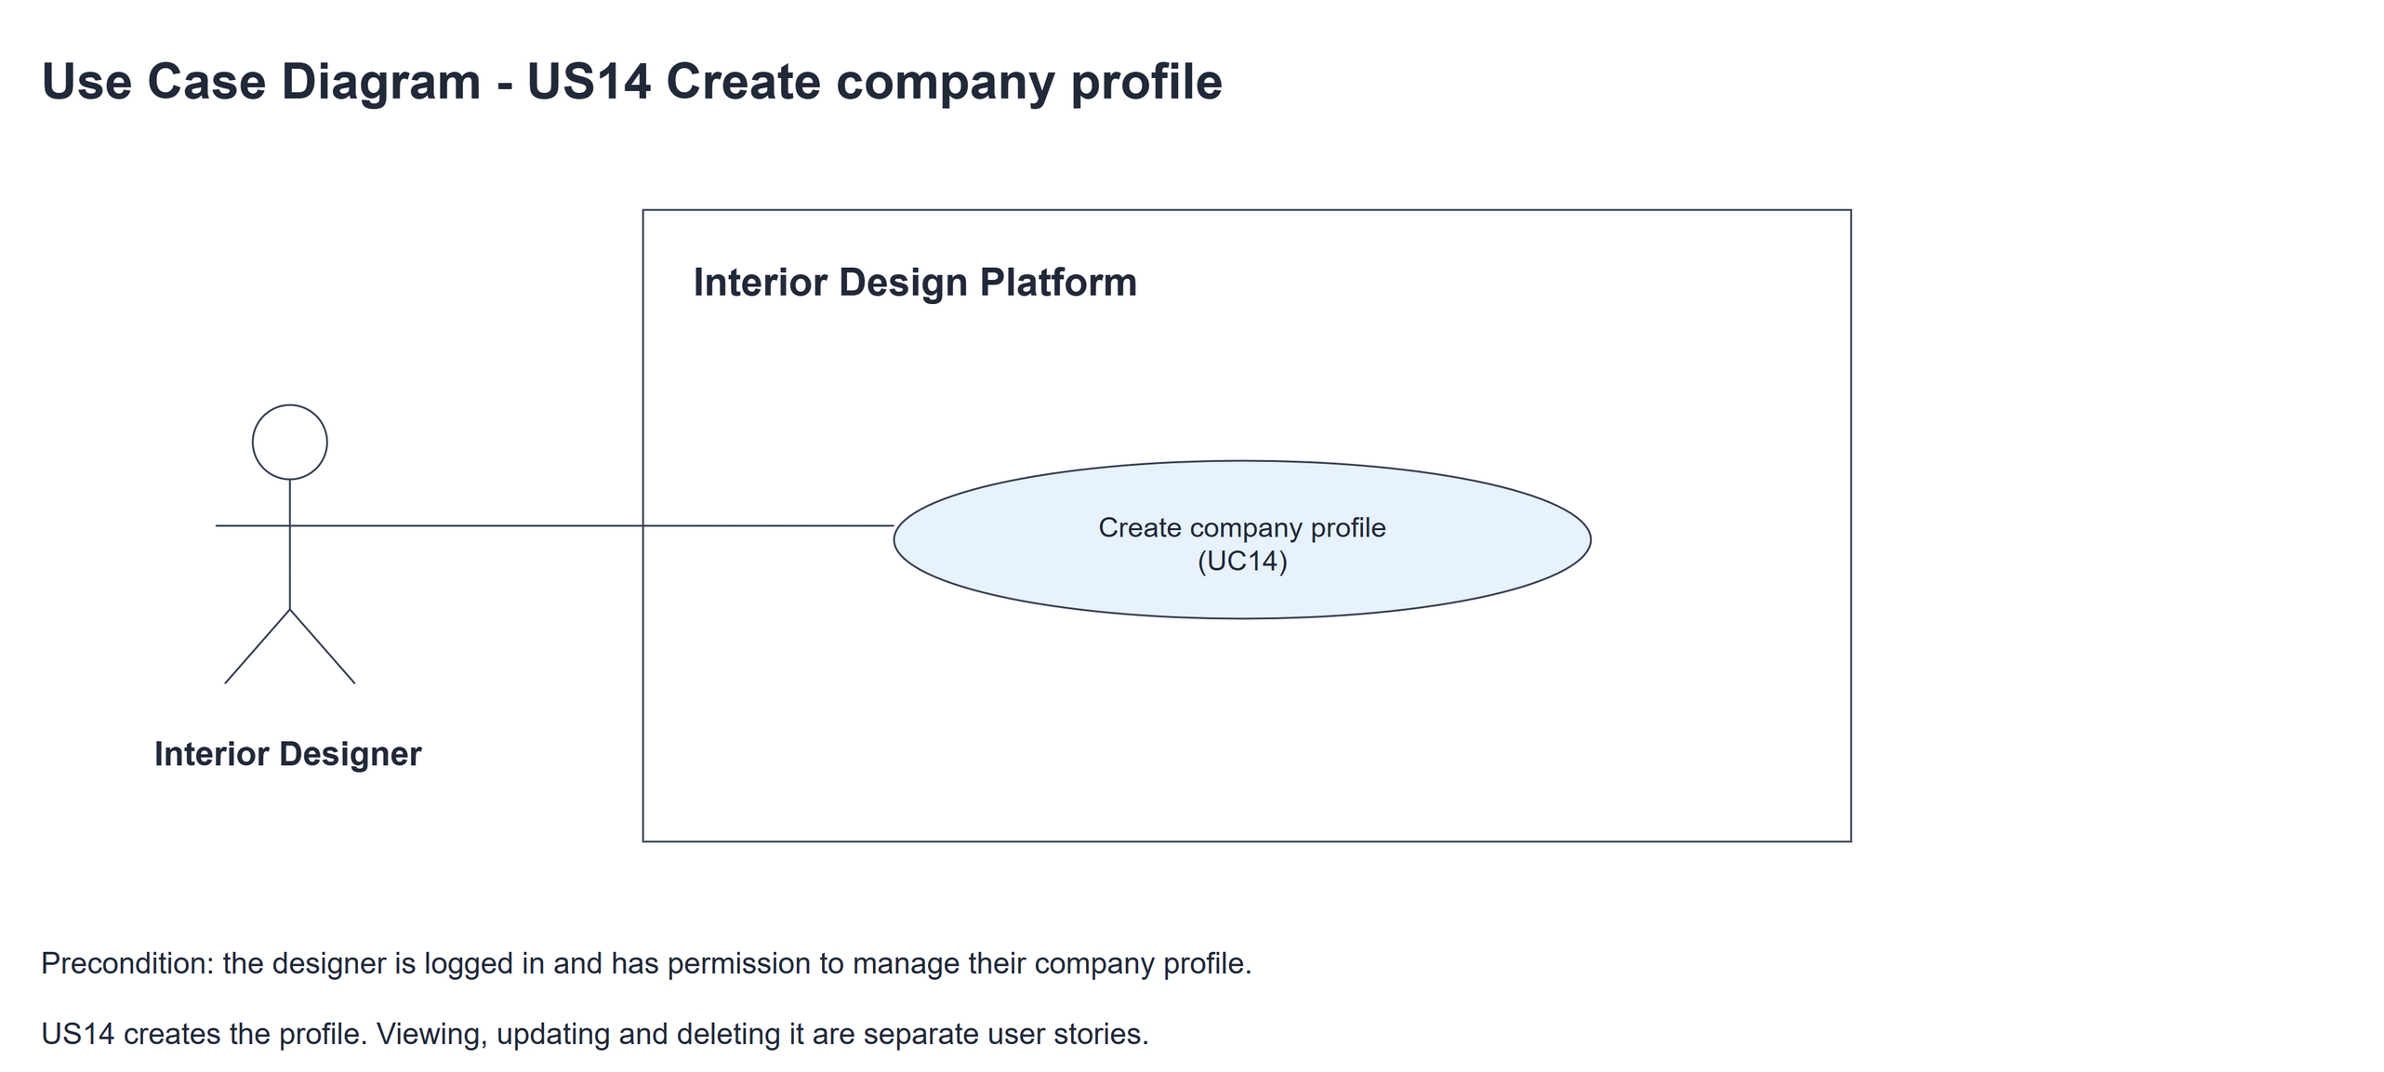
Figure 1: Use case diagram for US14 Create company profile

3. Use case description
Use case | UC14 Create company profile
Actor | Interior Designer
Brief description | The Interior Designer creates their company profile so customers can learn about the company and its services.
User story | US14: As an interior designer, I want to create a company profile so that customers can learn about my company and its services.
Preconditions | The Interior Designer is logged in (UC13). designerLoginRequired in app.py only sends someone with no session to /designer/login.
Trigger | The Interior Designer clicks "Create company profile" on the designer dashboard.
Basic flow | 1. The Interior Designer clicks "Create company profile".  2. The system shows the empty form.  3. The Interior Designer fills in the company details and clicks "Create company profile".  4. The system trims the spaces, puts the details in a CompanyProfile with the logged-in designer as the owner and checks the fields (required fields, lengths and email format).  5. The system checks that the designer has no company profile yet (Active or Suspended) and saves the new profile as Active.  6. The system shows the designer dashboard with "Company profile created successfully".
Alternative flows | 3a. The Interior Designer clicks "Cancel": the system goes back to the dashboard and nothing is saved.  4a. A field is wrong: the system shows "Please fix the highlighted fields", highlights the wrong fields and keeps what was typed. Back to step 3.  5a. The designer already has a company profile (Active, or deleted and not restored): the system shows "You already have a company profile" and nothing is saved. A deleted profile is brought back with Restore (UC17-R).
Postconditions | A new Active company profile is saved and linked to the designer.  The dashboard shows "View company profile" instead of "Create company profile".

4. Wireframes
The wireframes were drawn in draw.io. They are low-fidelity: they show the layout and the flow, not the final colours. The orange numbers match the notes under each screen.

4a - Create button
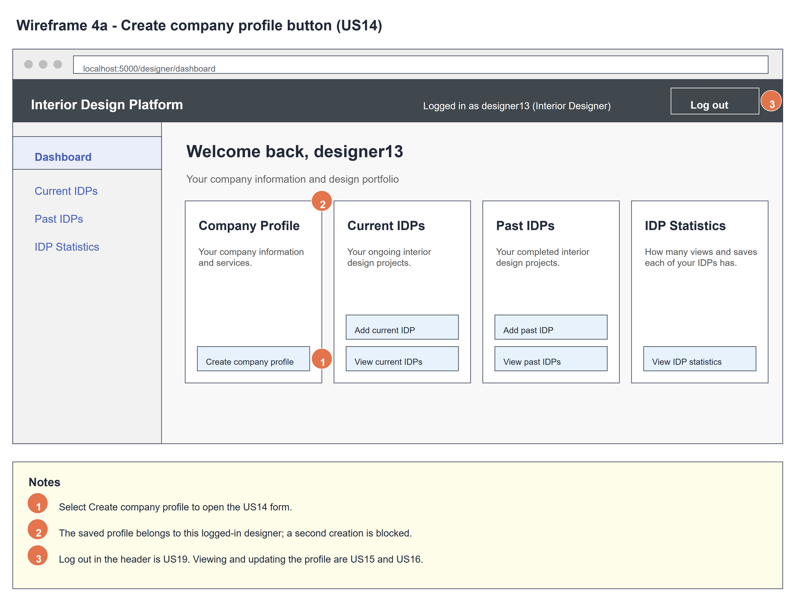
Figure 2: Wireframe 4a - Create button (US14)

4b - Create form
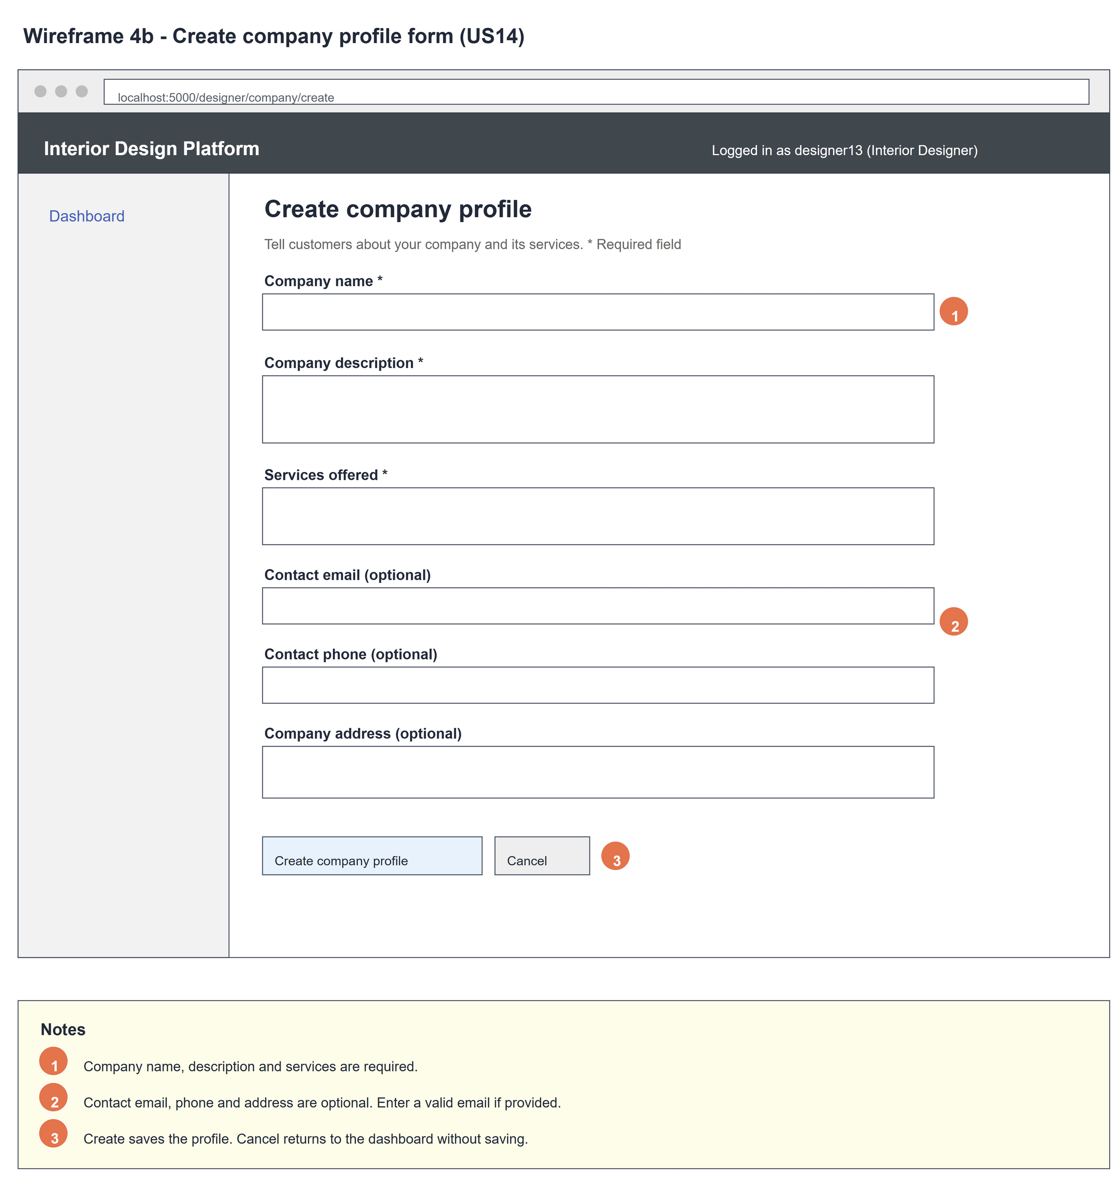
Figure 3: Wireframe 4b - Create form (US14)

4c - Form errors
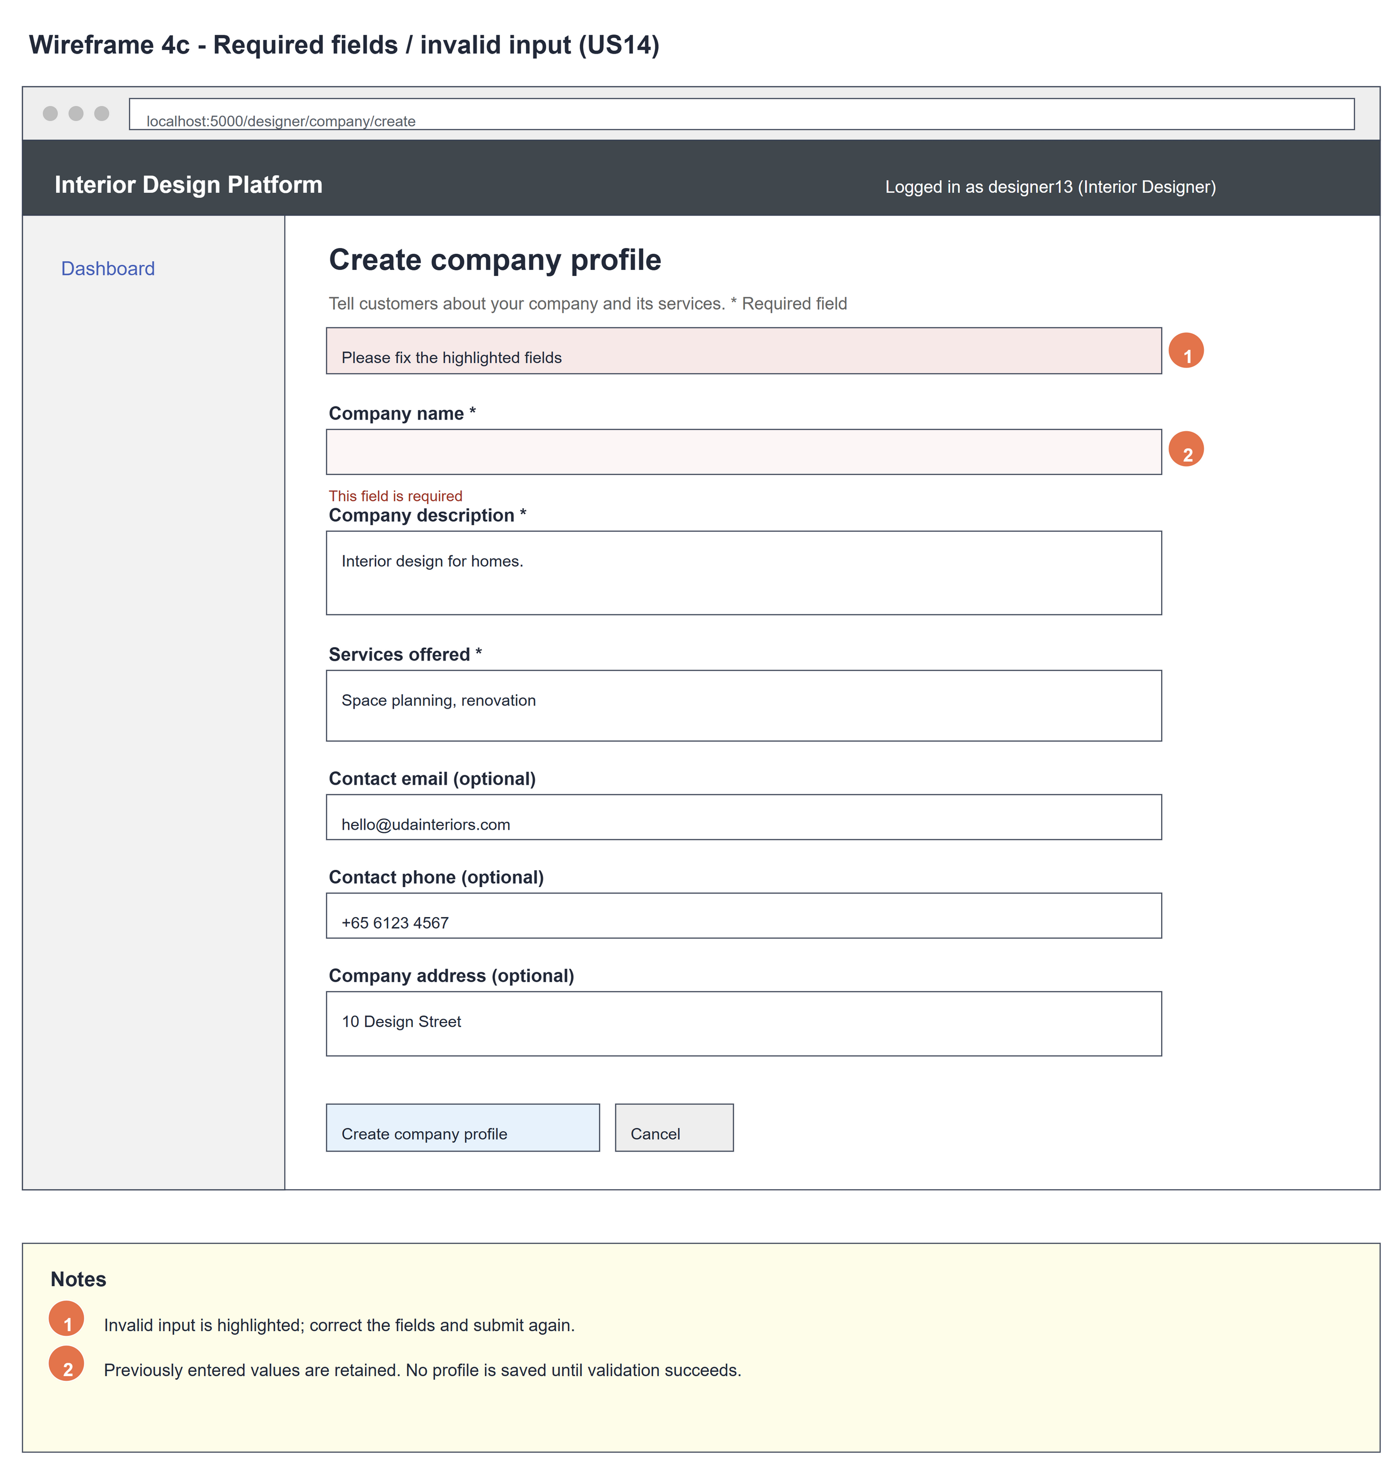
Figure 4: Wireframe 4c - Form errors (US14)

4d - Company created
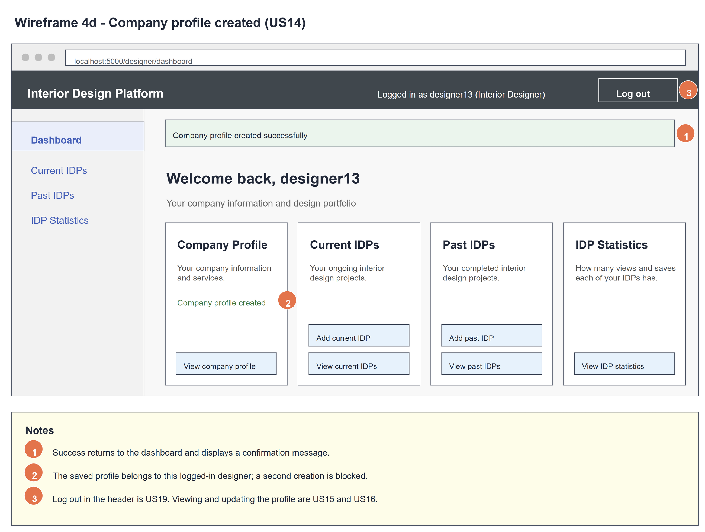
Figure 5: Wireframe 4d - Company created (US14)

4e - Existing profile
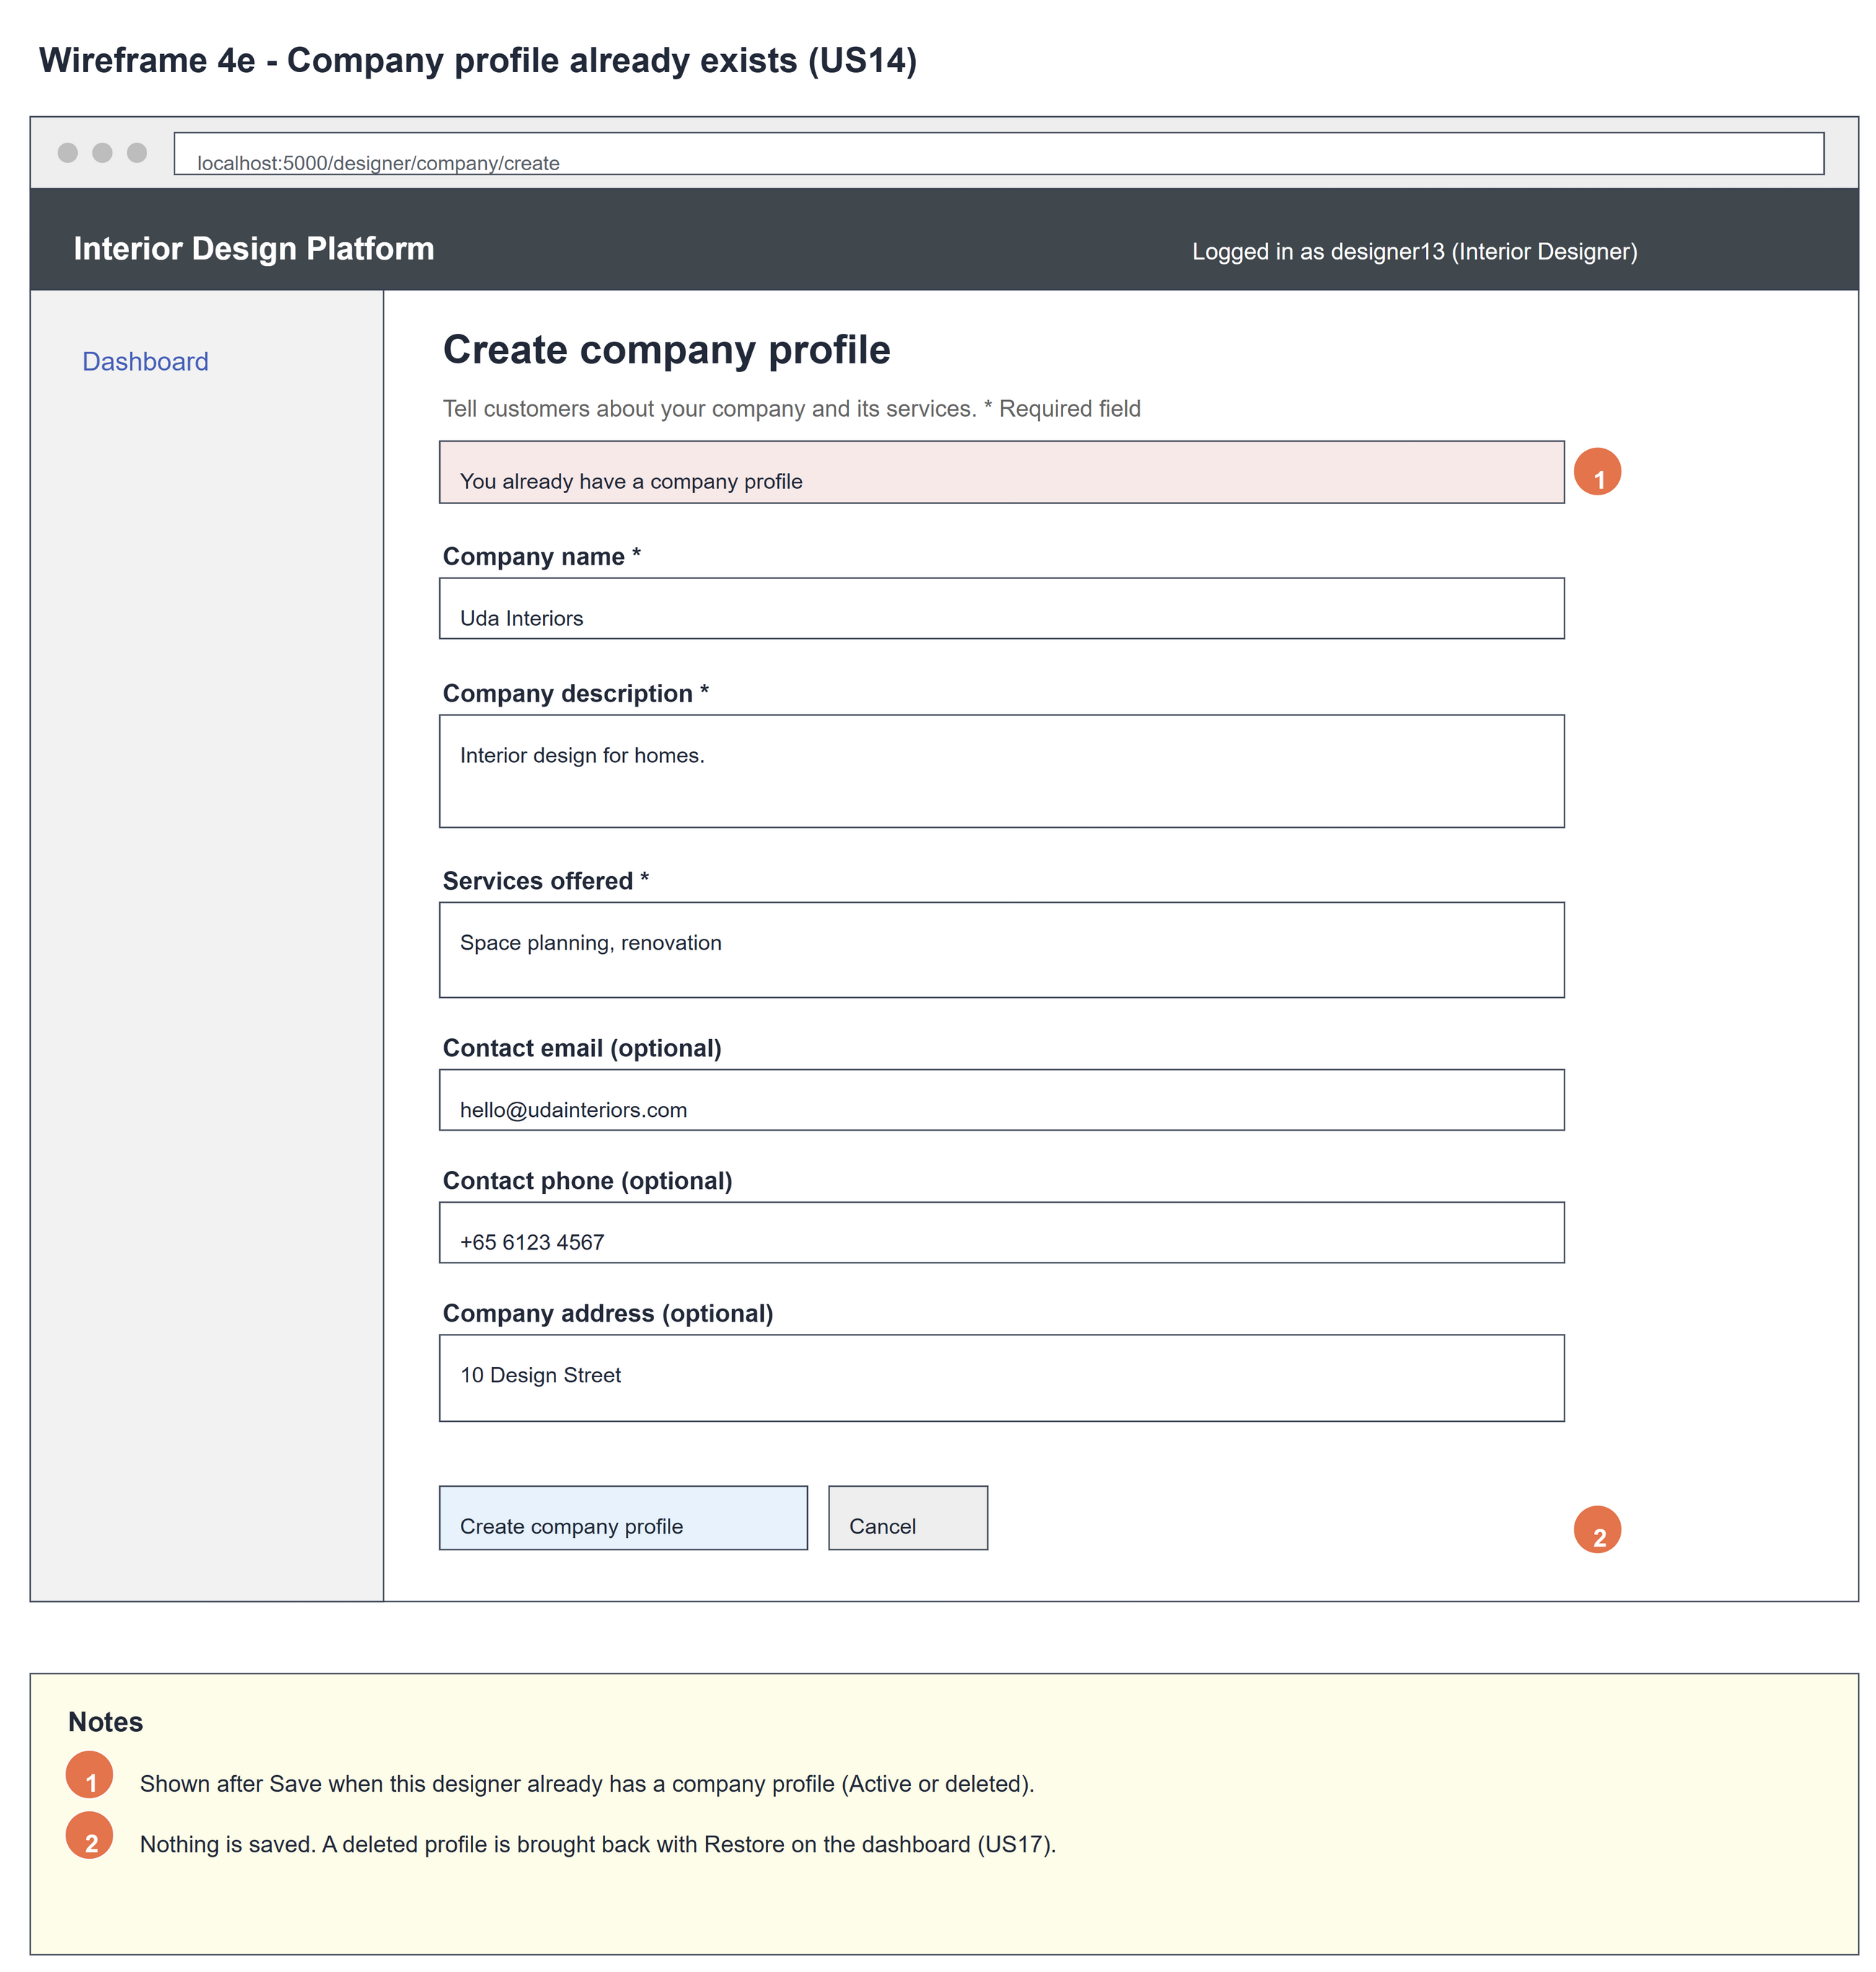
Figure 6: Wireframe 4e - Existing profile (US14)

5. B-C-E class diagram
The solid line means the boundary calls the controller. The dashed line means the controller uses the entity class. Only the operations needed for this use case are shown.
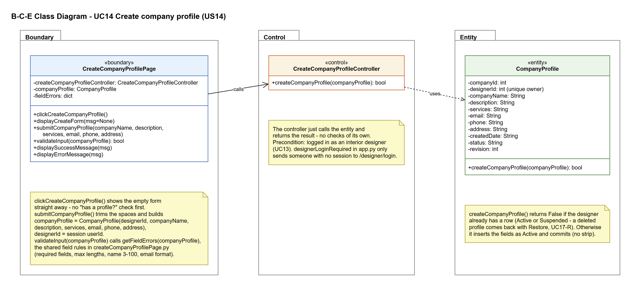
Figure 7: B-C-E class diagram for US14 Create company profile
Layer | Class | What it does
Boundary | CreateCompanyProfilePage | The create form. clickCreateCompanyProfile() shows the empty form straight away (displayCreateForm()). submitCompanyProfile() trims the input and builds a CompanyProfile with the owner from the session. validateInput(companyProfile) checks every field with getFieldErrors(companyProfile), the shared field rules in createCompanyProfilePage.py (US16 uses them too). Then it calls the controller and shows the result (displaySuccessMessage() or displayErrorMessage()).
Control | CreateCompanyProfileController | Controller for UC14. createCompanyProfile(companyProfile) just calls CompanyProfile.createCompanyProfile() and returns True or False - no checks of its own.
Entity | CompanyProfile | The company profile (company_profile table). createCompanyProfile() returns False if the designer already has a row (Active or Suspended); otherwise it inserts the fields as Active and commits. No trimming here.

6. Sequence diagram
The sequence diagram follows the basic flow of UC14. Clicking "Create company profile" shows the empty form straight away (steps 1-2) - there is no check for an existing profile first. When the form is sent, the page trims the input, builds a CompanyProfile with the owner from the session and calls validateInput(companyProfile) (steps 3-4). The outer alt covers alternative flow 4a: invalid input is caught by the page and the controller is never called. For valid input the controller makes one call to CompanyProfile.createCompanyProfile(), which refuses a second row for the same designer and otherwise saves the profile (step 5). The inner alt shows the success message (step 6) or "You already have a company profile" (alternative flow 5a).
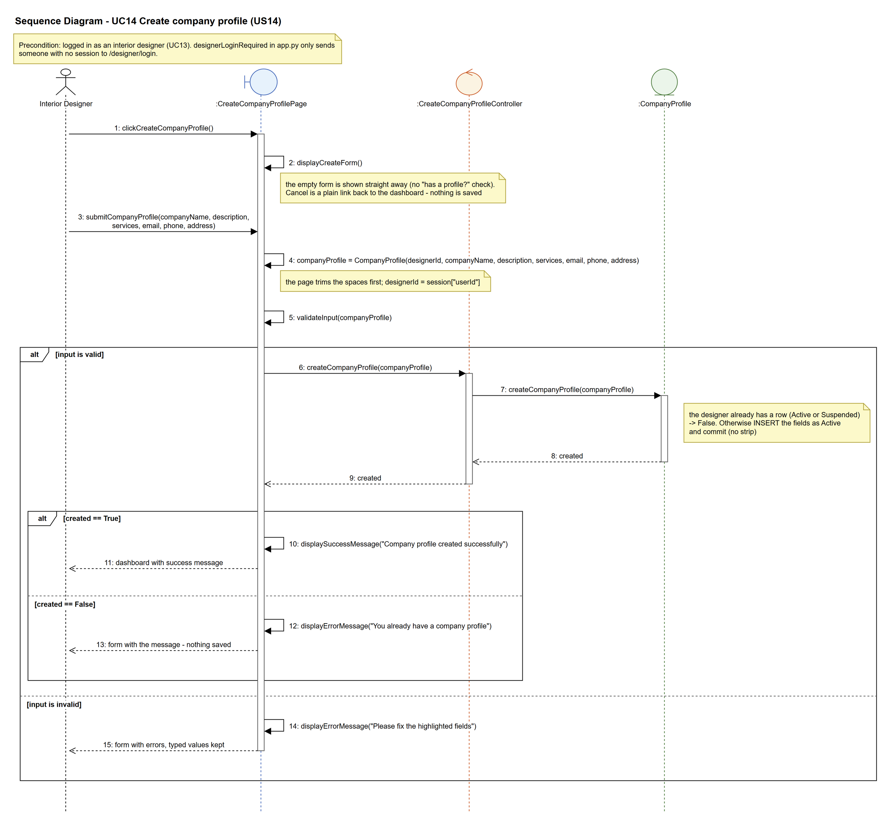
Figure 8: Sequence diagram for UC14 Create company profile

7. Test cases
Test data used below (same as database/seedData.py and the test files): user profiles User Admin (id 1), Interior Designer (id 2), Customer (id 3) and Platform Manager (id 4), all Active. User accounts admin01 / Admin@123 (User Admin) and cust001 / Cust@123 (Customer). The designer account designer13 / Design@123 (Tengku Uda Designer, Interior Designer profile) is made first with UC8. Company data: Uda Interiors, "Interior design for homes.", "Space planning, renovation", hello@udainteriors.com, +65 6123 4567, 10 Design Street.

7a. System test cases (black box)
Equivalence partitioning and boundary value analysis were used to pick the test data. Fill in "Actual result" and "Pass/Fail" after running each test.
Test ID | Scenario | Prerequisites | Test steps | Test data | Expected result | Actual result | Pass / Fail
TC14.1 | Create a valid company profile | Logged in as designer13. No company profile yet. | 1. Click "Create company profile"  2. Fill in the form  3. Click "Create company profile" | Uda Interiors, Interior design for homes., Space planning, renovation, hello@udainteriors.com, +65 6123 4567, 10 Design Street | "Company profile created successfully" on the dashboard. The dashboard now shows "View company profile".
TC14.2 | Optional fields left empty | Logged in as designer13. No company profile yet. | 1. Click "Create company profile"  2. Fill in only the required fields  3. Click "Create company profile" | Uda Interiors, Interior design for homes., Space planning, renovation | "Company profile created successfully".
TC14.3 | Required field missing | Logged in as designer13. No company profile yet. | 1. Click "Create company profile"  2. Leave company name empty  3. Click "Create company profile" | (empty), the rest as TC14.1 | "Please fix the highlighted fields" and "This field is required" under Company name. The other values are kept. Nothing is saved.
TC14.4 | Company name too short | Logged in as designer13. No company profile yet. | 1. Click "Create company profile"  2. Type a 2-character name  3. Click "Create company profile" | "Ud", the rest as TC14.1 | "Company name must be 3-100 characters". Nothing is saved.
TC14.5 | Company name exactly 3 characters | Logged in as designer13. No company profile yet. | 1. Click "Create company profile"  2. Type a 3-character name  3. Click "Create company profile" | "Uda", the rest as TC14.1 | "Company profile created successfully".
TC14.6 | Company name too long | Logged in as designer13. No company profile yet. | 1. Click "Create company profile"  2. Type a 101-character name  3. Click "Create company profile" | 101 x "A", the rest as TC14.1 | "Maximum 100 characters". Nothing is saved.
TC14.7 | Invalid email | Logged in as designer13. No company profile yet. | 1. Click "Create company profile"  2. Type an invalid email  3. Click "Create company profile" | not-an-email, the rest as TC14.1 | "Enter a valid email address". Nothing is saved.
TC14.8 | Already has a company profile | TC14.1 done. | 1. Open /designer/company/create  2. Fill in the form  3. Click "Create company profile" | Another Company, the rest as TC14.1 | The empty form opens first. After saving: "You already have a company profile". The existing profile is not changed. | The empty form opened. After saving, "You already have a company profile" was shown. The existing profile was not changed. | Pass
TC14.9 | Cancel | Logged in as designer13. No company profile yet. | 1. Click "Create company profile"  2. Type some details  3. Click "Cancel" | Uda Interiors | Back on the dashboard. No profile is saved.
TC14.10 | Not logged in | Not logged in. | 1. Open /designer/company/create | - | Sent to the designer login page. Nothing is saved.
TC14.11 | Deleted profile can't be created again | designer13's profile was deleted (UC17). | 1. Open /designer/company/create  2. Fill in the form  3. Click "Create company profile" | Uda Interiors Reopened, the rest as TC14.1 | "You already have a company profile". The deleted profile is kept and the dashboard still offers Restore (UC17-R).

7b. Unit test cases (for TDD)
These are written before the code (test-driven development) and run with pytest (python -m pytest). They cover normal inputs, abnormal inputs and boundary values. Each one matches a test function in tests/test_us14_createCompanyProfile.py (UT14.1 is test_ut14_1_...). "Pass" is from the pytest run on 9 November 2026.
Test ID | Class and method | Input / setup | Expected output | Type | Pass / Fail
UT14.1 | CreateCompanyProfileController.createCompanyProfile() | designer13's CompanyProfile with the company data | Returns True. Saved profile has companyName "Uda Interiors" and designer13 as owner | Normal | Pass
UT14.2 | CreateCompanyProfileController.createCompanyProfile() | Second create for the same designer ("Another Company") | Returns False. Still one profile, still "Uda Interiors" | Abnormal | Pass
UT14.7 | CreateCompanyProfileController.createCompanyProfile() | email, phone and address empty | Returns True | Normal | Pass
UT14.8 | CreateCompanyProfilePage.submitCompanyProfile() | POST companyName = " Uda Interiors " | The page trims it - saved as "Uda Interiors" | Boundary | Pass
UT14.9 | CompanyProfile.getCompanyProfile() | designerId 9999 | Returns None | Abnormal | Pass
UT14.11 | CompanyProfile.createCompanyProfile() | Same designer twice | True, then False. Only one row | Abnormal | Pass
UT14.12 | CreateCompanyProfileController.createCompanyProfile() | designer13 and designer14 | Each gets their own profile (2 rows) | Normal | Pass
UT14.13 | CreateCompanyProfilePage.validateInput() | Valid company data | Returns True | Normal | Pass
UT14.14 | CreateCompanyProfilePage.validateInput() | companyName = "" | Returns False. fieldErrors has companyName | Boundary | Pass
UT14.15 | CreateCompanyProfilePage.validateInput() | description = "" | Returns False | Boundary | Pass
UT14.16 | CreateCompanyProfilePage.validateInput() | services = "" | Returns False | Boundary | Pass
UT14.17 | CreateCompanyProfilePage.validateInput() | email = "not-an-email" | Returns False | Abnormal | Pass
UT14.18 | CreateCompanyProfilePage.validateInput() | companyName = 101 x "A" | Returns False | Boundary | Pass
UT14.19 | CreateCompanyProfilePage.clickCreateCompanyProfile() | GET /designer/company/create as designer13 | Form with all six fields | Normal | Pass
UT14.20 | CreateCompanyProfilePage.submitCompanyProfile() | POST the company data | "Company profile created successfully". One profile saved | Normal | Pass
UT14.21 | CreateCompanyProfilePage.submitCompanyProfile() | POST with companyName empty | "Please fix the highlighted fields". Typed description kept. Nothing saved | Abnormal | Pass
UT14.22 | CreateCompanyProfilePage.submitCompanyProfile() | POST when a profile already exists | "You already have a company profile". Still one profile | Abnormal | Pass
UT14.23 | designerLoginRequired (app.py) | GET /designer/company/create, not logged in | Redirects to /designer/login. Nothing saved | Abnormal | Pass
UT14.25 | CreateCompanyProfilePage.submitCompanyProfile() | Form includes designerId = 1 | Profile saved for designer13, not for user 1 | Abnormal | Pass
UT14.26 | Cancel link on the create form | Open the form | Cancel links to /designer/dashboard. Nothing saved | Normal | Pass
UT14.27 | Designer dashboard (UC13) | designer13 with no profile | Shows the "Create company profile" link | Normal | Pass
UT14.28 | Designer dashboard (UC13) | designer13 with a profile | Shows "Company profile created" and no create link | Normal | Pass
UT14.30 | CreateCompanyProfilePage.displayErrorMessage() | description = "<script>alert(1)</script>" with an error | Text is shown escaped (&lt;script&gt;), not run | Abnormal | Pass
UT14.31 | seedCompanyData() | Run twice | First run makes 100 profiles, second run makes 0 | Normal | Pass
UT14.32 | CreateCompanyProfileController.createCompanyProfile() | CompanyProfile with status "Suspended" | Returns True. Saved as Active | Boundary | Pass
UT14.33 | CompanyProfile.createCompanyProfile() | designer13's profile deleted with suspendCompanyProfile(designerId, companyId, expectedRevision), then create again | Returns False. The Suspended row and its details are kept, still one row | Abnormal | Pass
UT14.34 | CreateCompanyProfilePage.clickCreateCompanyProfile() | GET /designer/company/create when designer13 already has a profile | The empty form is shown (no message before Save). Nothing changes | Normal | Pass
UT14.35 | CreateCompanyProfilePage.submitCompanyProfile() | POST when designer13's profile was deleted (Suspended) | "You already have a company profile". /designer/company gives 404. Still one row | Abnormal | Pass

